Name ______________________________ Date _______________

Lesson Planning Cheat Sheet!

“Learning has nothing to do with what the TEACHER COVERS. Learning has to do with what the STUDENT ACCOMPLISHES.”

LESSON PLANNING: What are the benefits? Why can’t I just “wing it”?
- Prepare interesting lessons that engage students, adapt to their learning styles, and appeal to their interests
- Have confidence in having a clear plan successful delivery of lesson
- Present lesson in a logical, clear, intentional way
- You and your students will benefit!

- BEFORE LESSON
Part of Lesson | Purpose | Example
Objective | 1-3 objectives each starting with “Students will be able to…” | “Students will be able to explain the concept of trust in God by comparing the experience of Abraham to an experience in their own life.
Materials | List out all the materials you will need for this lesson. This way, you can easily gather what you will need. | - Instrumental music  - Bible  - Handouts (send to parish by Wednesday night)  - Scratch paper for exit ticket  - Projector (book beforehand)
Assessment | Formative or summative, to inform you of what kids have learned that day, who to challenge, who to reteach. | - Exit tickets  - Checklist  - Anecdotes of observations
Time | How much time are you allotted? Make sure your plans WILL fit the time you have. | Break each part of your lesson into chunks to keep yourself on pace.

- DURING LESSON
ME! | Prayer | Write out the prayer. Try to have it connected to the passage or the theme of your lesson for the day. Try a variety of prayers that will encourage students to use that method in their daily life. If kids are old enough, you can encourage them to take care of the opening prayer. | - Bible passage  - Lectio Divina  - Written prayer  - Song
 | Review | Do a quick review (quick whip-around, game, entrance ticket, etc.) of what was taught last week, to build upon this week’s lesson, or to keep it fresh in mind. | - 3 facts on index card  - White boards  - Think-Pair-Share
 | Opening/Hook | How can you engage student’s attention from the get-go? How can you connect an experience that they are familiar to what your lesson will be, so they can better understand the concept? | - Guess this object  - Tell a story  - Video clip
WE! | Lesson Delivery | The “meat” of your lesson, where you deliver the CONTENT to cac em. | - Storytelling  - Demonstrations  - Debate/discussion  - Inquiry/discovery
 | Check for Understanding | Do students have the knowledge that matches your objective so far, to be successful when they try on the skill or do the next activity? | - Exit ticket  - Observations
YOU! | Independent Practice/  Activity | This is where students get a chance to practice what you taught, or engage in an activity that will help reinforce their understanding and lead them further to your objective. | - Games  - Crafts  - Journaling
Summary/Closing Prayer |  | Return back to the objective.  End with a prayer. | - Teacher tells  - Students tell/write
Follow-Up/HW |  | What will be in store for the next lesson?  If you decide to give HW, make sure it allows students to review AND put your objective into ACTION in their daily lives. | - Log of practicing the skill  - Journal entry  - Stay away from just “coloring”

- AFTER LESSON
Analysis/Reflection | What went well? What didn’t go according to plan? Why? How can you change next week’s lesson based on that information? Looking at your assessments, sort them into categories:  - Who met my objective?  - Who was close, but has some small misunderstandings that can easily be corrected?  - Who needs some reteaching/review?
Games and Activities
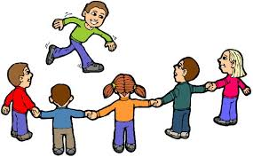
Do’s
- Make it “Bible-licious”!
- Think about the space/resources you have
- PLAN! Make it intentional for learning purposes
- Prepare the rules or directions beforehand and explain them clearly, step by step
- MODEL the game first before letting them loose, better yet, test it out with some friends to see if it will be effective
- Not all lessons HAVE to have a game or activity
- It should support and enforce the learning and objective of your lesson
- Explain the reason why we are doing the activity/game
- BE ENERGETIC AND ENTHUSIASTIC!! If you are not excited to play your game, why should your students be?

Don’ts
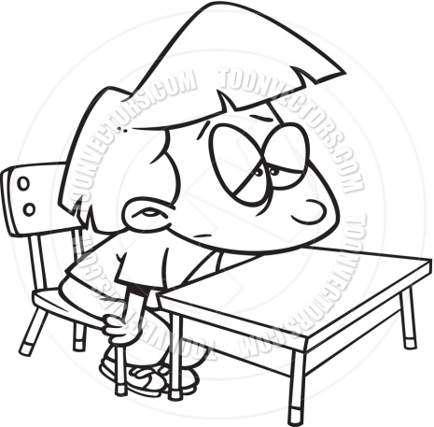
- Use it as a “time-killer”
- Play a random game that comes to mind, no point to it except for “fun”
- Have the students “only be coloring something”; brainless
- Give something that has too many rules/criteria/hard to keep track of
- No examples, just explanation and then launch right into it

Record-Keeping

Purpose of keeping records:
- Track student attendance and progress
- Provides evidence to support your grading decisions

Things to consider:
- Know what the standards and expectations are for the class you are teaching
- You can keep track either in a notebook, a spreadsheet, on your computer…whatever works for you.
- Don’t fall behind! Grade your papers or activities for the day and enter them into your gradebook so it doesn’t pile up.

Ways to Keep Records
Checklist
Anecdotal Notes
Class Record Charts
Folders
Assessments

Formative | Summative

Student answers
Student work:
- worksheets
- projects
- activities
Exit tasks
Quizzes, exams
- Written
- Oral
- Projects/Presentations

Is homework a good way to assess student learning?

